Curriculum Vitae

Personal Details

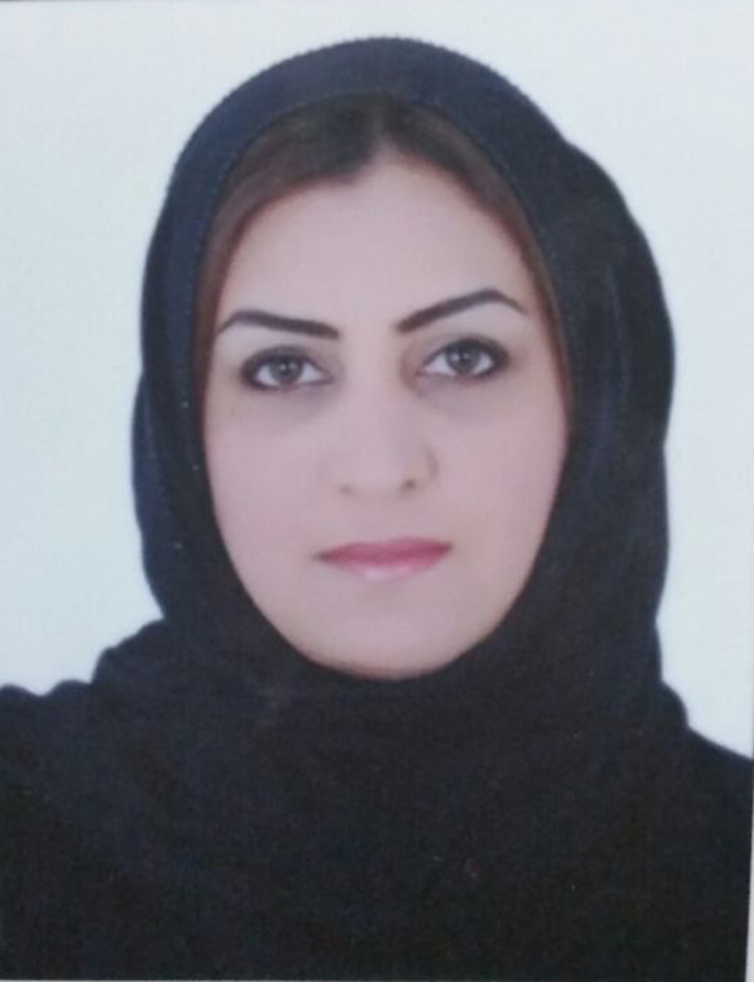
- Name : AMAL ABDULLA MOHAMMED AL-ASWAD
- Nationality : Bahraini
- Date of Birth : 20th of Jan 1986
- Address : House 186, Road1007, Block210,
Muharraq
- Contact No. : 33709114
- CPR. : 860103153
- Marital Status : Married
- E-mail : um-reem-86@hotmail.com

OBJECTIVES

To be a productive professional in your organization where I can apply and develop my skills, knowledge and experiences in a challenging and growth oriented position.

Highlights

- Excellent verbal communications and interpersonal skills.
- Strong ability to work well with others as part of a team.
- Keen to demonstrate skill set and potential
- Strong customer service focuses and able to coordinate multiple tasks.

EDUCATION

- 2004

Isa Town Secondary Girls School, Secondary School certificate, Media

Computer skills

- MS Office world.
- MS Office PowerPoint.
- MS Office Excel..
- Typing speed
- operating Internet browser

Other skills

- Self motivated
- Team working and good communication skills
- Ability to work well independently and under pressure
- Good knowledge of using office equipment
- Ability to adapt to new systems and applications

Work Experience

EL NASR FOR IMPORT AND EXPORT
Work in as Secretary

- calling customers and companies .
- scheduling appointments.
- Handling the appointment.

The autumn fair 2012
Sales

- managing the whole shop.

Last chance
working as caisher

Languages

- English (spoken -written-reading)
- Arabic (Mother Language)

